**DINNER @ HOCKING COLLEGE**

**CORNERSTONE**

**RULES FOR THE UPWARDLY MOBILE**

***You have to learn the rules of the game. And then you have to play better than anyone else. Albert Einstein (1879-1955)***

**PURPOSE:**

There are rules in every facet of our lives, rules to games, rules of civil society—laws, rules within the workplace and in organizations we belong to, there are also rules to living within poverty, living within the middle-class and living within wealth.

Wherever you seek to stake your claim in the world, you will need your playbook to include the rules and be able to use those rules to your advantage to succeed. Tonight is about the rules of upward mobility.

I have lived in poverty and I know for sure I do not want to live there again. How many of you hear tonight seek to live in poverty 5 years from now? Well when I was in College, I know I did not want that either and so learning the rules and developing my playbook to be upwardly mobile worked for me and it will work for you if you choose to invest yourself to get there. That is why I am so passionate about what we are doing here at Hocking College to give our students a leg-up as a Hocking alumnus.

**BACKGROUND:**

Just like products that we associate good thoughts or negative in their brand we each have our own brand, a personal brand. Your brand is communicated in the first 11 seconds of meeting. It is communicated through body language, dress, hygiene, social interaction and finally in words we say. Your brand is identified by the way others would describe you similar to the way you describe a product with a brand name you know. What are the words being used to describe you? That is your brand.

Today many employers will ask a candidate for a job to go to lunch or to dinner. Too often, we think that is a nice social gesture and we become relaxed and stop interviewing. In fact the rules of the game tell us that this social interaction is a continuation of the interview and will give the employer a greater insight into who you are, your mindset, and untimely help them determine if you will be a good “fit” in the job you are interviewing for.

Another good reason you may want to take everything you can away from tonight is that you might want to impress a date at some time in the future.

Most of us have eaten a lot of lunches and dinners out of a paper bag, off a cafeteria tray, or in the original container out of the microwave. Many families no longer sit together for meals missing the opportunity to pass along the lessons of social graces of the upwardly mobile and in some families; these upwardly mobile rules of the game may not be well known or understood. For whatever reason we know from talking to employers, our program advisory committees and others that while our students are well qualified in terms of their skills and knowledge in the programs we offer that we could do better in the area of professionalism, emotional intelligence and social skills.

What exactly are we talking about here? Knowing the rules of the workplace including things like

* Dressing for the role and for upward mobility(ress
* Speaking in a professional tone, inflection, and use of language that represents the role and your upward mobility.
* Etiquette with a phone
* Basic table manners and etiquette for more sophisticated situations
* Professional graces such as shaking hands appropriately and understanding overall body language
* Knowing what to talk about over a dinner meeting and knowing what not to talk about
* Knowing how to introduce yourself to a stranger and how to introduce others
* The ability to make others comfortable when interacting with you

This is a sample of the rules of the game; areas of professionalism and social smarts that will set you up for success and upward mobility.

**DINNER EVENT:**

Everything that you will experience at the dinner event is choreographed to give you the rules and to let you determine how you will write your playbook to WIN.

As you entered the building tonight there was a receiving line where you had the opportunity to practice a handshake and self-introduction. Do you recall the names of those you met?

Ways to remember names and help others remember your name

* Repeat the name “it is very nice to meet you Joseph”
* Associate their name with someone else that might help you remember “I have an uncle Joseph”
* If it is a difficult name ask them to spell that for you and give a sincere compliment such as “that is a beautiful name, is that a family name?” What you are doing here is focusing on the name, which will help you in remembering the name.
* To help others remember your name use a phrase or connect to another famous person. I use, “my name is Betty Young, you’re going to remember that because I will always ‘B Young;” This usually enlists a chuckle and a smile which helps to make a connection with the individual.

You checked in to the RSVP table as you would at a larger corporate or charitable event you might be attending on behalf of your employer. There you received your table number and had the opportunity to interact with those helping deliver this event. Did you thank them for your table number? How did you go about doing that?

Ask for examples:

* Thank You
* I very much appreciate your guidance
* Thanks, I am looking forward to this evening

Recognize your host and watch for clues from the host. This way you will know when to take your seat at your table and other signs as the evening progresses.

You might say to your host:

* Thank you for invitation I am looking forward to this evenings events
* What a great venue, thank you for making this evening possible

Keep in mind your host has many guests arriving and do not monopolize their time.

* I wanted to say hello and I will let you greet your others guests
* I look forward to meeting some of the people here tonight, I wanted to say hello and thank you for the invitation

A typical social gathering such as the one planned for tonight, with many guests, begins with a social period typically ½ to one hour. This is a time for everyone to get checked in and have something to drink and/or light snacks while mingling and chatting with other guests.

The host will typically let you know when dinner is ready to begin and you will take your seat.

**DINNER ETIQUETTE:** 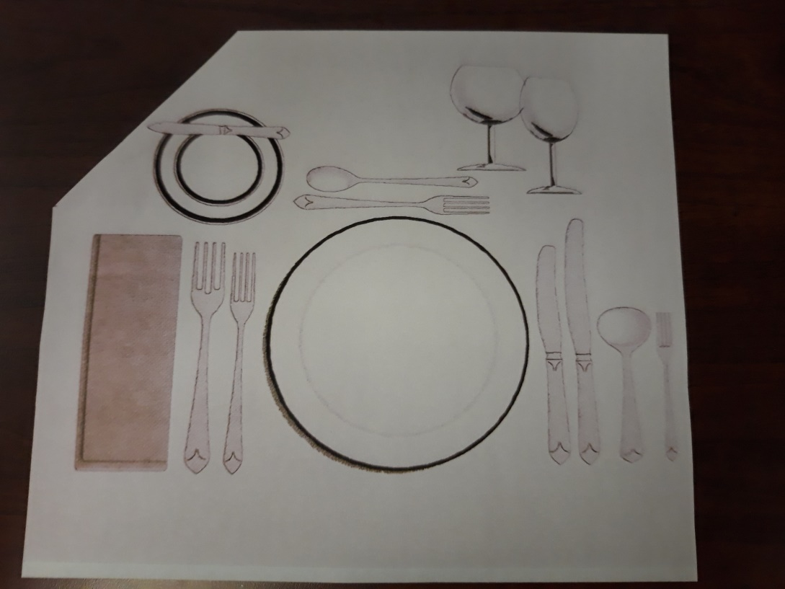

**Dinner Plate** is the largest plate in the center used for the main entrée or may be used as an under-plate for soup. At very formal meals, there may be a charger, which is a large and used for decorative purposes only. It may be removed when you sit down or your meal may be used under soup and or salad. It will be removed before the main entrée is served.

**Bread and Butter Plate** is the smaller plate located above the forks on the left side of the place setting.

**Glasses** included above are the water goblet, the largest glass and is placed closest to the center of the place setting. The smaller glass is the wine glass.

***Tip:*** *Think of having a BMW in front of you, left is Bread, Middle is Meal, and W is Water.*

**Utensils,** the number and quantity depend on the courses of the meal served. Remember to start from the outside and work in toward the meal plate as each course progresses.

**Cocktail fork** is the smallest fork and is used for seafood appetizer and is located next to the soup spoon on the right of the plate. This will be the only fork found on the right side.

**Salad fork** will be on the far left side and is the smaller of the two forks in a typical informal meal setting.

**Dinner fork** is the largest of the forks and located next to the meal plate.

**Dinner knife** is the largest of the knives.

**Butter spreader** is a small knife found across the top of the bread and butter plate. It is used only to spread butter on a piece of bread, as you are getting ready to eat it or to take butter from the butter dish if no communal butter knife is supplied.

**Butter knife** is a communal knife used to cut the butter in the butter dish and move it to your individual plate. Replace it on the butter dish and do not use it to butter your bread, this is not your personal knife.

**Soup spoon** is the rounder of the spoons and typically has a shorter handle.

**Dessert spoon and fork** is located at the top of the meal plate. There may be only one of these depending on the dessert being served.

**Teaspoon** is used for coffee or tea. In a formal setting, it will be brought to the table with the teacup. It may also be used for dessert at a less formal meal.

**PROPER USE OF UTENSILS:**

**Holding the utensils for cutting food (American Style)** by placing the knife on the open palm of your dominant hand with the handle in your palm and the top of the blade sharp side facing down. Place the fork in your non-dominate hand, handle in your palm and the tines facing up. Cut gently, avoid sawing. Use the fork to spear the food and cut above never between the tines of the fork. Cut and eat only one bite at a time after switching hands for the fork to the dominate hand.

**(European or Continental style)** allows you to place the fork tines down in your non-dominate hand knife in dominate hand same as American style. Once you have cut one piece of food without switching hands and with the tines of the fork down, move the food to your mouth. The knife is also used to push other food on the plate, which cannot be stabbed by the tines, onto the back of the fork. The entire meal is eaten in the manner, even if the food does not require cutting.

**Resting** during the meal lets your waitperson know that you are not finished with your meal, place the utensils on the plate, but not next to each other. Never allow any part of the utensil to rest on the table once it has been used.

**Finish** is a signal to the waitperson that you are finished and they may remove your plate. Do this by placing the utensils handles at 4 o’clock on the plate, fork on the left tines up and knife sharp edge facing the fork.

***Tip:*** *Do not return a used utensil to the table. Place it on the plate and it is the responsibility of the waitperson to bring you another one or to ask you to keep your current one. If asked to keep it look for a spot that will not foul the table such as the bread plate.*

**NAPKIN USE:**

**Before the meal** pick up the napkin, move it to your lap without unfolding it. Once n your lap, unfold it so it is folded in half. The fold is placed closest to your body with the edges toward your knee. As you use the napkin use the open and inside of the napkin do dab, never wipe your lips.

**During the meal** keep the napkin in your lap. If you leave the table, excuse yourself, place your napkin neatly on your chair, and push your chair under the table.

**After the meal** after everyone has finished and it is time to exit the table the napkin may be neatly placed to the left of the plate. Do not refold the napkin and never scrunch a paper napkin into a ball or place it on your plate.

***Tip:*** *Never use the napkin as a handkerchief, to clean the silverware, or your eyeglasses. Wait for the host to signal the meal is ended by placing their napkin in the finish position on the table before you proceed to do likewise.*

*If you are wearing dark clothes, you may not want to place a white napkin on your lap because of lint, ask the waitperson for dark linen or if wearing white and dark napkins are provided ask for white. On a final note, ask for items to be passed don’t overextend your reach and keep your elbows off the table.*

**More from The Playbook for Upward Mobility:**

* Avoid **alcohol consumption** if you are underage, no exceptions, you never want to be known as one who breaks the rules. If you are legal age to consume alcohol then in moderation i.e. a glass of wine, or one cocktail would be appropriate if you see your host is also partaking. If not you will want to enjoy a similar beverage as your host, i.e. a soft drink.
* **Body Language** at the table helps you digest your food and make a good impression with your tablemates. Sit straight with your feed and legs of chair on the floor. **Look up from your food** and focus on your tablemates during the meal
* **The business meal is not about the food** it is about the social interaction and relationship building that will enhance your success, the food the media not the goal.
* **Conversation, small talk,** is important to avoid acquired silence. Stay away from controversial topics for social and business gatherings such as politics and religion. Opt instead for asking others about a good movie they have seen, traveled anywhere interesting, what they enjoy when not working, and asking about work is also appropriate. Focus on the other people at your table and not on yourself and you will be well on your way to a successful event.
* **Other Decorum for Dining:**
  + **Wait before eating** until everyone at the table is served and your host begins. Your host may suggest you start if it is a large group or if something is delayed.
  + **Do not blow on your food** soup may be stirred, forward and back, and other food simply wait for it to cool.
  + **Don’t make a pig of yourself** in a buffet or similar setting do not pile an excessive amount of food on your plate, remember these meals are about the relationship being built not the food. Take only one of items brought to you such as bread or
  + **Don’t stuff your mouth** chew quietly and with your mouth closed.
  + **Don’t play with your food** **or criticize** and be willing to try everything. This is not a time to complain about what was served simply enjoy as much as you can and move on.
  + **Don’t pick your teeth.** Do Not put your fingers in your mouth, sip a beverage and discreetly loosen any caught food with your tongue. It is also appropriate to excuse yourself and go to the restroom. Never use a toothpick at the table.
  + **Do not belch.** If you do accidently excuse yourself quietly.
  + **No seconds.** Do not ask for seconds unless they are offered.
  + **Salt and Pepper** travel together.
  + **Taste food before seasoning.** It may be insulting to the chef to season your food without first tasting it.
  + **Leave spoon on saucer.**
  + **Toasting**, a host may toast a guest of honor or vice versa at the beginning of a meal. The person being toasted does not drink. It is not necessary to clink glasses together, this was done traditionally to drive evil spirits away. If someone advances to you to clink the glass do so but no need to initiate this gesture yourself. Instead simply raise your glass for the occasion.

**CONCLUSION:**

Remember, this lesson is about you building your professional brand, a brand that will help you reach the success you desire in your personal and professional life. You are the one in charge of what that brand will be and with intention you will build strong relationships and networks. Your brand is discovered by listening to what others will say when describing you. If you like what you hear build upon that brand and if you don’t be intentional about building the brand you desire. I wish you each the best in your personal journal to become the person you want, to achieve the career and personal goals that make you happy.

If I can ever be of assistance to you in your journey know you can contact me and I am in your corner.

My sincere Best Wishes

Dr. Betty Young